

Artificial Intelligence

Lab 04



February 13, 2019

Muhammad roshan mughees

193590

Preprocessing Task:

from PIL import Image

#PREPROCESSING

image_file = Image.open("sign.jpg")

image_file= image_file.convert('1') # convert image to black and white

image_file.show()

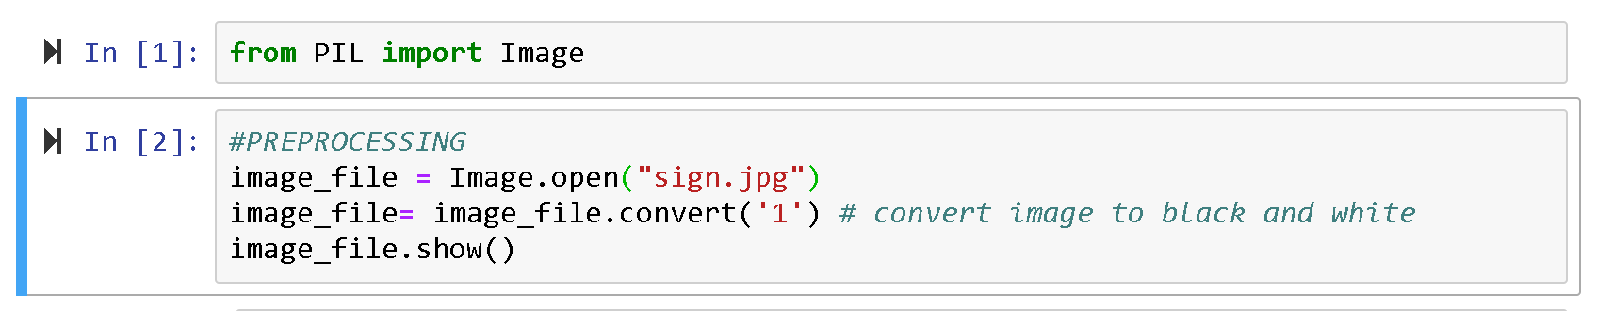

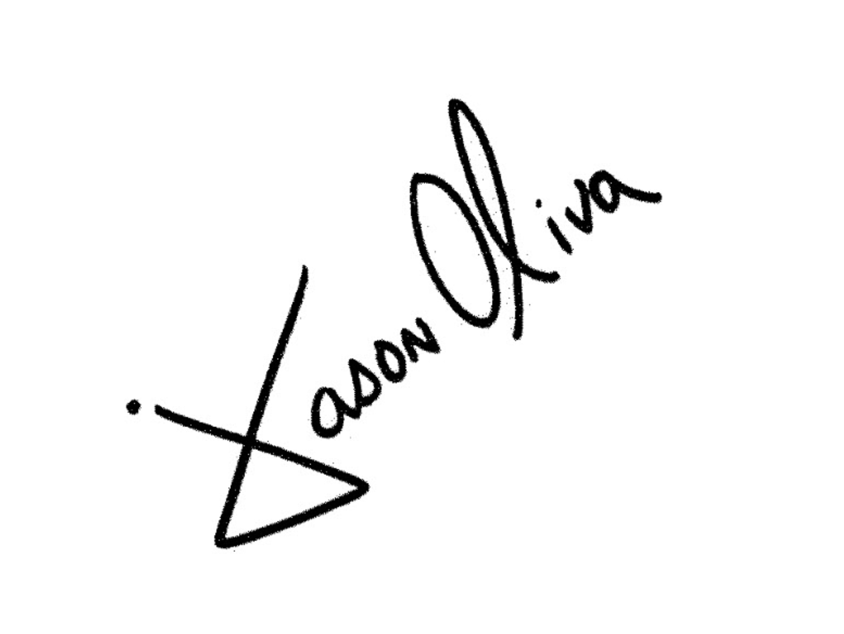

Task 1:

#TASK 1

import itertools

left,top= image_file.size

right,bottom = 0,0

for x,y in itertools.product(range(0,image_file.size[0]),range(0,image_file.size[1])):

color = image_file.getpixel((x,y))

if color is 0:

if x>right:

right = x

if x<left:

left =x

if y>bottom:

bottom = y

if y<top:

top = y

print (left,right,top,bottom)

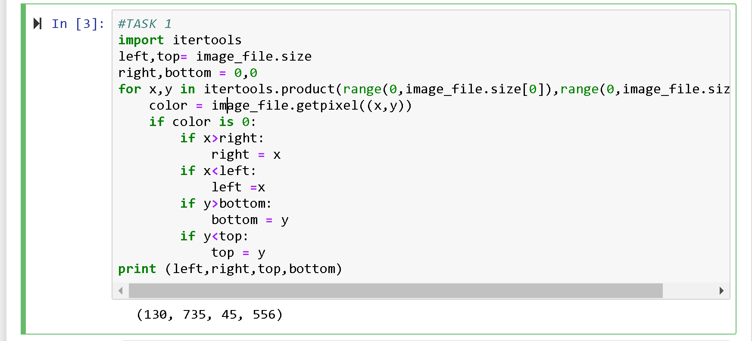

Task 2:

#TASK 2

cx=0

cy=0

n=0

for x,y in itertools.product(range(0,image_file.size[0]),range(0,image_file.size[1])):

if image_file.getpixel((x,y)) is 0:

cx=cx+x

cy=cy+y

n=n+1

cx=cx/n

cy=cy/n

print(cx,cy)

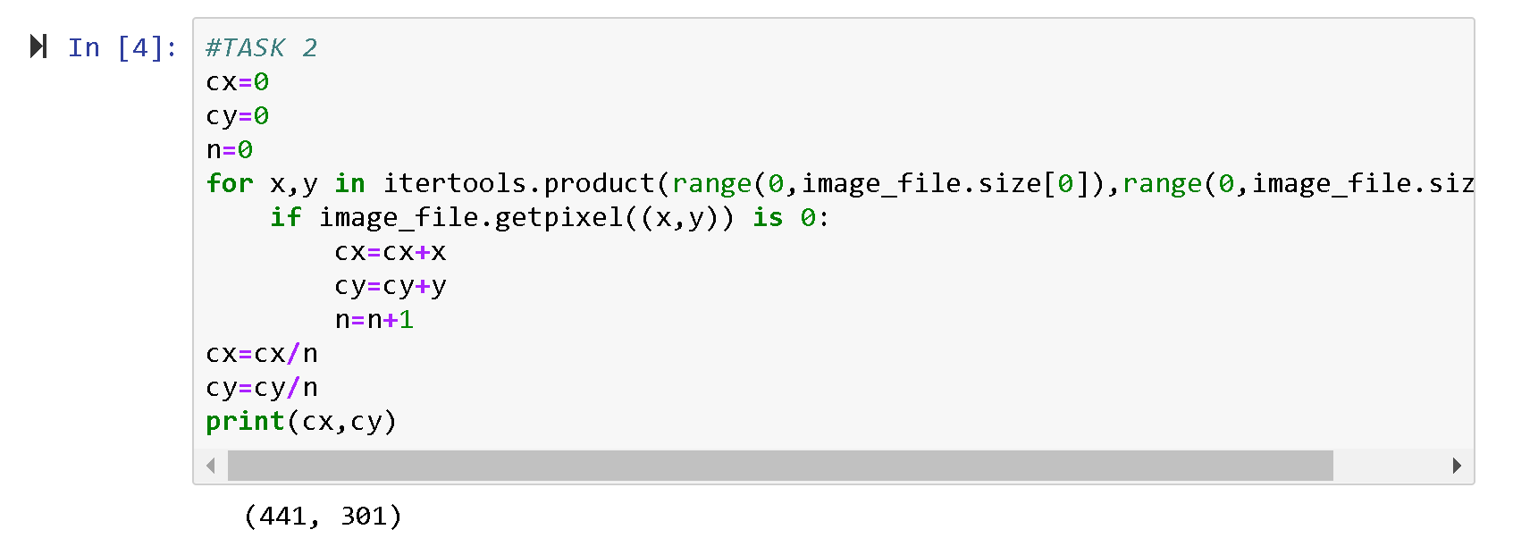

Task 3:

#TASK 3

from PIL import Image, ImageDraw

draw = ImageDraw.Draw(image_file)

draw.rectangle(((left, top), (cx, cy)))

draw.rectangle(((right,top), (cx, cy)))

draw.rectangle(((left, bottom) ,(cx, cy) ))

draw.rectangle(((right, bottom) ,(cx, cy) ))

image_file.show()

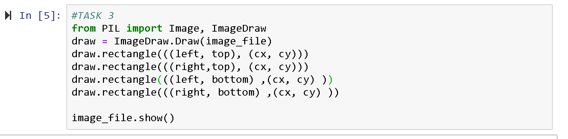

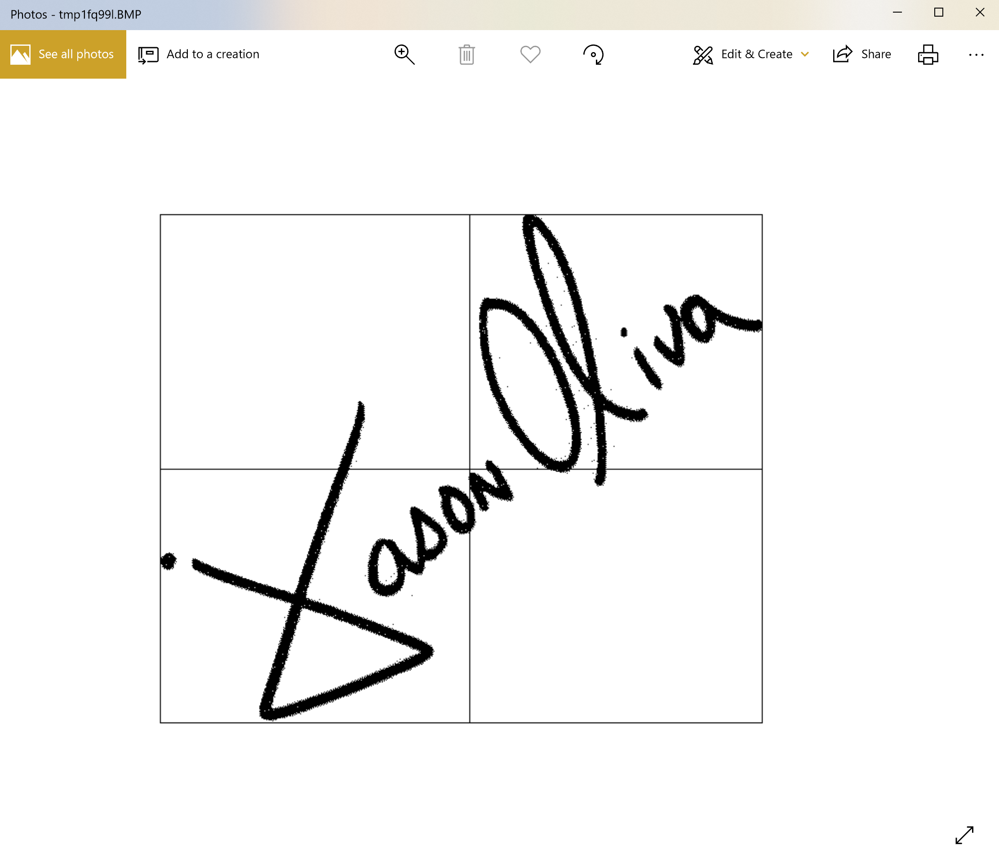

Task 4:

def whitetrans(left,right,top,bottom):

width=right-left

height=bottom-top

prev = image_file.getpixel((0,0))

n=0

for x,y in itertools.product(range(1,width),range(1,height)):

cur = image_file.getpixel((x,y))

if cur is 255 and prev is 0:

n=n+1

prev = cur

return n

#TASK 4

print (whitetrans(left, cx, top, cy))

print (whitetrans(cx, right, top, cy))

print (whitetrans(left,cx,cy,bottom))

print (whitetrans(cx,right,cy,bottom))

